|  |
| --- |
|  |
| |  | | --- | | John X. Wang | | My Working Roadmap | | My Comprehensive Guide | |  | | Draft 1 | 25 February 2016 | |

|  |  |  |
| --- | --- | --- |
| This report takes into account the particular  instructions and requirements of our client.  It is not intended for and should not be relied  upon by any third party and no responsibility  is undertaken to any third party.  Job number xxxxxx |  | ArupLogo2010_k_OvaWord1000mm_CompoundTransparent_100kGreyscale.wmf |
|  |
| **Ove Arup & Partners Hong Kong Ltd**  Level 5 Festival Walk  80 Tat Chee Avenue  Kowloon Tong  Kowloon  Hong Kong  www.arup.com |

|  |  |  |  |  |  |  |  |  |  |  |  |
| --- | --- | --- | --- | --- | --- | --- | --- | --- | --- | --- | --- |
| Document Verification | | | | | | ArupLogo2010_k_OvaWord1000mm_CompoundTransparent_100kGreyscale.wmf | | | | | |
|  | | | | | |  | | | | | |
|  | | |  | | | | |  | | | |
| Job title | | | My Working Roadmap | | | | | Job number | | | |
| xxxxxx | | | |
|  | | |  | | | | |  | | | |
| Document title | | | My Comprehensive Guide | | | | | File reference | | | |
|  | | | |
|  | | |  | | | | | | | | |
| Document ref | | |  | | | | | | | | |
|  | |  |  |  | | | | | | | |
| Revision | | Date | Filename | Report.docx | | | | | | | |
|  | |  |  |  | | | | | | | | |
| Draft 1 | | 25 Feb 2016 | Description | First draft | | | | | | | |
|  | Prepared by | | Checked by | | Approved by | | | |
| Name |  | |  | |  | | | |
| Signature |  | |  | |  | | | |
|  | |  |  |  | | | | | | | | |
|  | |  | Filename |  | | | | | | | |
| Description |  | | | | | | | |
|  | Prepared by | | Checked by | | Approved by | | | |
| Name |  | |  | |  | | | |
| Signature |  | |  | |  | | | |
|  | |  |  |  | | | | | | | | |
|  | |  | Filename |  | | | | | | | |
| Description |  | | | | | | | |
|  | Prepared by | | Checked by | | Approved by | | | |
| Name |  | |  | |  | | | |
| Signature |  | |  | |  | | | |
|  | |  |  |  | | | | | | | | |
|  | |  | Filename |  | | | | | | | |
| Description |  | | | | | | | |
|  | Prepared by | | Checked by | | Approved by | | | |
| Name |  | |  | |  | | | |
| Signature |  | |  | |  | | | |
|  | | | | | | | | | | |
| Press **Control+Shift+D** to insert or remove DV sheet | | | | Issue Document Verification with Document | | | |  | ✓ |  |
|  | | | | | | | | | | |

Contents

Page

[1 1](#_Toc342563262)

References

Tables

Figures

Drawings

Pictures

Photographs

Attachments

Appendices

1. Air Ventilation Assessment
   1. Why need AVA study

7. What is Outline Zoning Plan?

Outline Zoning Plan(OZP) is a kind of statutory plan prepared by the Town Planning Board under the Town Planning Ordinance. It is basically a plan that shows the land-use zonings and major road systems of individual planning scheme areas. Each plan is accompanied by a Schedule of Notes which show for a particular zone the uses always permitted (Column One Uses) and uses that would require permission from the Town Planning Board (Column Two Uses) upon application.

12. When is a S.16 application required?

Each Outline Zoning Plan is accompanied by a Schedule of Notes showing the uses always permitted (Column One Uses) and uses that would require permission from the Town Planning Board (Column Two Uses) within a particular zone. There may be additional controls on developments within a particular land use zone and these are specified under the 'Remarks' column in the Notes for that land use zone. You only need to apply for permission under S.16 of the Town Planning Ordinance when your proposed use or development is under 'Column Two' or as required by the 'Remarks' of the Notes.

14. What can I do if the proposed use neither falls within Column One nor Column Two Uses?

You may submit an application for amendment of plan under S.12A of the Town Planning Ordinance. The S.12A application form and the 'Guidance Notes' on how to apply are available at the Planning Enquiry Counters, and could also be downloaded from the Town Planning Board's website.

*FAQ in PlanD:* [*http://www.pland.gov.hk/pland\_en/info\_serv/faq/#q12*](http://www.pland.gov.hk/pland_en/info_serv/faq/#q12)

Preparation: wind data, project building drawings, GIS data

Wind data:

1. RAMS
2. Wind tunnel experiment
3. AVA register
4. HKO weather station

Project building drawings:

1. Site location plan, Master layout plan
2. Ground floor plan, first floor plan, second floor plan, typical floor plan, roof plan of each block
3. Committed/planed/future development (WIP in OZP map <town planning board>, Lands Department map)
4. Noise barriers location

Team shared GIS data:

*N:\Knowledge Management\TechnicalInformation\Digital\_Map\HK\_Map\\_HONGKONG*

1. Wind availability study
2. Building environment modelling
3. Model meshing
4. Run Simulation
5. Result processing
6. Report
7. Response to Comment
8. Reference
   1. Scope of work and fee quote

Stage 1 – Conceptual Design

|  |  |  |
| --- | --- | --- |
| Scope of work | Duration | Fee |
| * Review all available wind data * Provide guidelines for developing conceptual design * Attend two meetings with project team and 1 meeting with PlanD * Simple report | 1-week | HK$70,000 |

Stage 2 – Detail Design for S12A

|  |  |  |
| --- | --- | --- |
| Scope of work | Duration | Fee |
| * Prepare methodology statement * Conduct AVA Initial Study for 1 Baseline Scheme and 1 Proposed Scheme as per current AVA Technical Circular * Attend all meetings with project team, if necessary, and 3 meeting with PlanD/ TPB * Full report | 4-week | HK$300,000 |
| * Each additional scheme |  | HK$140,000 |

* + 1. Preparation work

1. Site Plans (site boundary)
2. MLP/each floor plan
3. Development Parameter
4. Future/Committed/Proposed Development
5. Noise barriers
   * 1. Wind availability study

Wind data selection priority

For AVA study

1. Wind Tunnel Experimental data

They can be found in the PlanD website, covering all the districts in Hong Kong.

But the experimental data are given in the form of normalised mean wind speed, which should be converted to mean wind speed by multiplying an assumed wind speed at 500m, say 10m/s or 7.2m/s, as it would not affect the VR. (7.2m/s is suggested to use as it is the wind speed at infinity (around 600m) of Waglan Island Weather Station, suitable for all districts of Hong Kong)

If the normalised wind speed "1" is appeared at 200m or 300m, assume all winds at 500m are 7.2m/s and then calculate proportionally.

2. RAMS from PlanD website

3. AVA register (Expert Evaluation – wind corridors)

4. MM5 model (retired)

For MC study

1. Wind Tunnel data

2. winter condition: use the wind rose of RAMS to identify the wind direction, but use the wind profile of Wind Tunnel

Note:

The wind characteristics (Wind rose pattern, directional wind frequency) of the annual and summer prevailing winds is similar at 500m throughout Hong Kong, although the magnitudes of the directional wind speeds are reduced.

Sometimes, if MC and AVA were carried out together, wind tunnel data would be adopted for consistence in both study.

Reference:

1. ~\Documents\Site\_Wind\_Availability@Wind\_Tunnel@TuenMun.pdf
2. ~\Documents\Site\_Wind\_Availability@Report@SaiKung\_WP4a\_SWAS+EE\_Draft@20150318.pdf
3. ~\Documents\Site\_Wind\_Availability@Report@TP7H\_on\_Preliminary\_AVA(28-00)\_Issue2@25-09-2013.pdf
   * 1. Building environment modelling

Find needed GIS data to build model

Basic information received is a cad file and pdf file, showing below. You can find the site boundary line. Using surrounding building as the reference point, match it with GIS data. Then, confirm the GIS grids needed to build the 3D model.

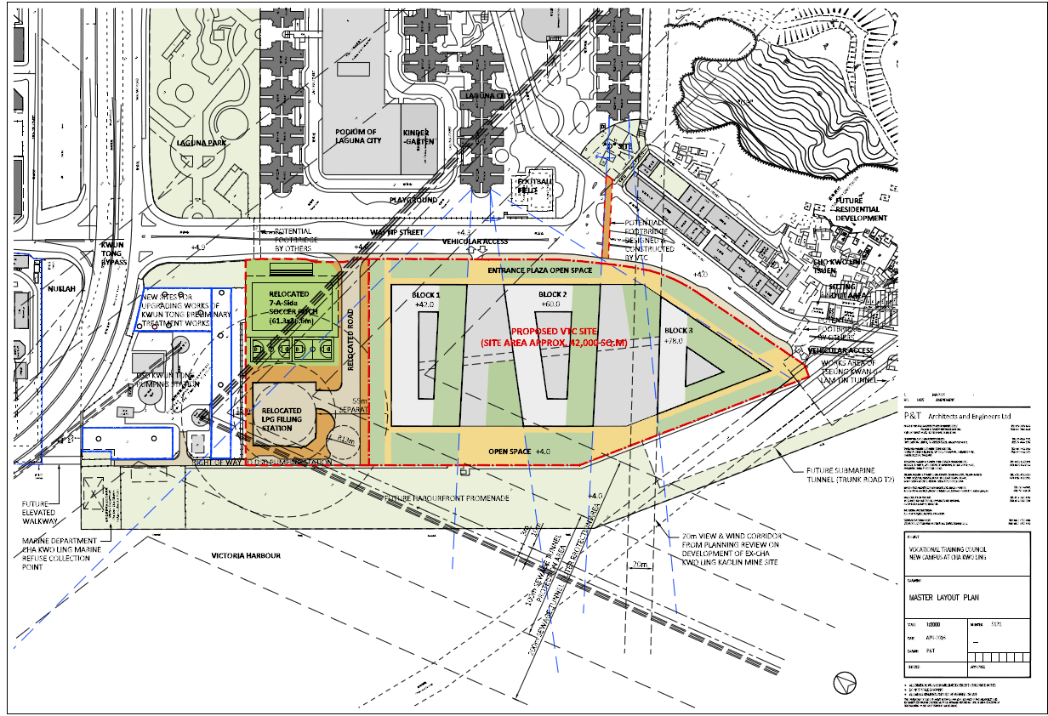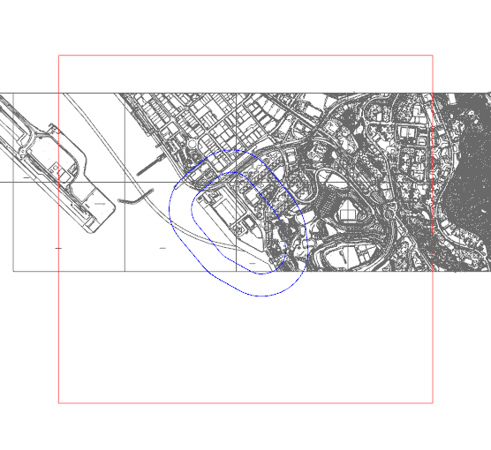

The number label in GIS data system refers to:

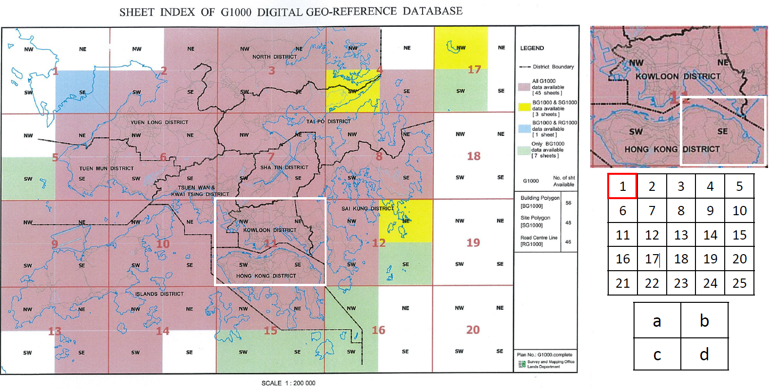

*~\Lib\GIS\_Hong\_Kong\Instruction*

Make topography, refer to next section

Check the buildings, e.g. Committed Development, Planned Development, Noise Barriers, Covered walkway and Pedestrian Bridges etc.

Topography must keep identical except site area between Baseline and Proposed Scheme.

2 m Topo need to be extracted as STL file for further use in CCM.

* + 1. Run Simulation

Save every 10 iteration steps by script. (difficulty: change of saving name by variable)

Export test points by script

Too long time cost in exporting contour by STL file

* + 1. Result processing

Test points are placed at where people would pass frequently, such as road, playground, school, park etc.

* + 1. Working Procedure

Refer to: ~\Documents\AVA@Instruction@Procedure@Camby.doc

~\Documents\AVA@Instruction@Procedure@Wilson.doc

* + 1. Reference

1. ~\Documents\AVA@Exp\_Summary@Emma.pptx
2. ~\Documents \AVA@Report@Expert\_Evaluation@MaOnShan.pdf
3. ~\Documents\ [AVA@Technical\_Circular.pdf](mailto:AVA@Technical_Circular.pdf)
4. ~\Documents\AVA@Policies\_Guidelines@Paper@Edward\_Ng.pdf
   * 1. Possible mitigation measures

Stepped building/podium height Profile

Free podium

Wind corridor

Building separation

Building layout/orientation assist penetration of annual and summer prevailing winds

Building setback

* + 1. Report writing skills

Characteristics of Study Site and its Surrounding Area

* OZP map is a good tool to identify the area of the surroundings as well as the range or mountain name (http://www2.ozp.tpb.gov.hk/gos/default.aspx?)

Attentions

1. If the VR value of a focused area is less than 0.1, indicating the wind environment here is much worse. So make sure the VR value for this focus area in Proposed Scheme is not worse than that in Baseline Scheme. E.g. 0.08 Vs 0.07 is not acceptable while 0.11 Vs 0.10 may be acceptable.
2. Have a big picture in mind for the wind performance. Find the main feature under annual wind and summer wind. Say where is the project site located, windward or leeward, exposed to open area or mountain area?
3. Compare the wind performance based on Proposed Scheme, higher or lower?
4. Among three schemes, first compare Intermediate Scheme and Proposed Scheme with Existing Scheme, then compare Proposed Scheme with Intermediate Scheme.
5. Description must be specific (the Development of Proposed Scheme, downwash along its southeastern facade into pedestrian level)
6. Similar flow pattern under some wind directions could be grouped together and take one wind as an example to demonstrate.

Overall Ventilation Performance

* First mention the similarity of all the studied schemes, such as, which region got higher VR (open space) and lower VR (clusters of buildings) and explain reason briefly.
* Then describe the differences of between schemes and explain reason briefly, such as blockage of the Development, divertion, downwash, setback, penetration. Referred to the result of focus area as well as wind enhancement features, it is easy to find out under which winds the differences are resulted in.

Directional Analysis

* First similarity (from which direction the wind approaching Project Site? Where is the VR higher or lower)
* Then difference (with reference to result of focus area as well as wind enhancement feature)

Good Description/ Expression on Wind

1. Winds approaching from the north and north-north-east were the least affected due to the area’s relatively open exposure in those directions.
2. A portion of wind coming from Cha Kwo Ling Road would ventilate across the Study Area under Existing Scheme in the absence of significant infrastructure
3. On the other way round, the Intermediate and Proposed Schemes would capture the incoming wind and split it into two airstreams to travel along Wai Yip Street and Cha Kwo Ling Road

Drawing Format in plot

Wording font 9 for street name, building name

White, Black, Yellow, Blue, Red

*Refer to ~\Doc\AVA@DirectionalAnalysis\_Mark.docx*

Phrase

noun

Sea – open water

Shielding effect/ blockage/ obstruction/ shading

NE quadrant, SW quadrant

Air path (wind corridor is an exclusive term. Be careful when using it)

Lower VR/ higher VR - Calm/ windy

Presence of the existing infrastructure

Incoming wind Vs approaching wind (direction not same as the incoming wind)

Alignment

Hilly range/ Mountain

Building frontage

Explain reason

Result in/ lead to

Due to/ caused by/ because of/ as/ for

Verb.

Downwash/ divert /guide/deflect

Facilitate/ favour

Be achieved/ be resulted

Create a wake zone/ cast a wind shadow

Distort

Flow/ travel/ serve/ enter/ distribute

Found/ taken place

Minimize/ alleviate/ mitigate/ compensate

Comply/ conform/ in line with/ in accordance with

* 1. Microclimate Study

Preparation: wind data, project building drawings, GIS data

Time: PDRC – BC – DDRP1 – DDRP2

Content:

1. External wind environment
2. Odour Dispersion
3. Indoor Ventilation for Common Areas
4. Indoor Ventilation for Domestic Flats
5. Sunshadowing Study
6. Vertical Daylight Study/Average Daylight Factor
7. Glare Study
8. Outdoor Thermal Comfort
9. Indoor Thermal Comfort
   * 1. Preparation work
10. Full layout drawings (in pdf and CAD) including MLP, G/F, 1/F, T/F,R/F,UR/F and any other non –typical floor
11. Full set window schedule
12. Landscape layout – outdoor thermal comfort study
13. RCP and RSMMR exhaust flow rate, louver dimension and location, free area for odour study
14. BIM model for glare study
15. Typical external wall and roof material layer for indoor thermal comfort study
    * 1. Daylight Study

Example:

void plastic gloss\_white\_paint

0

0

5 1 1 1 .03 .01

[5 R G B specularity roughness)]

Acceptable values:

1. colour [0:1],[0:1],[0:1] Min 0, Max 1, black – white
2. specularity [0:1] Min 0, Sug. Max, matte – satin
3. roughness [0:1] Min 0, Sug. Max, polished - low gloss

Example:

void glass glass\_window

0

0

3 .96 .96 .96

3 R\_transmission G\_transmission B\_transmission

Acceptable values:

Transmission, Min 0, Max 1 black - transparent

* + 1. Vertical Daylight Study/Average Daylight Factor (IEQ15)

The preferred method[[1]](#footnote-1) as suggested in the BEAM Plus v1.2 Manual was used to estimate the ADF. ADF is derived from the simulated value of VDF based on the following formula:

$$ADF=\frac{Wτθ}{A_{r}\left(1-{R_{r}}^{2}\right)}=\frac{2VDF∙Wτ}{A_{r}\left(1-{R_{r}}^{2}\right)}$$

The calculation parameters are summarised in Table 1 below.

Table Calculation Parameters for ADF Study

|  |  |
| --- | --- |
| **Calculation Parameter** | **Value / Source** |
| $VDF$: Vertical Daylight Factor | Simulated using Radiance (please see below) |
| $W$: Window Area | Calculated from Architectural Drawing |
| $τ$: Visible Light Transmittance | 0.85 |
| $A_{r}$: Total Internal Surface Area | Calculated from Architectural Drawing |
| $R_{r}$: Area-weighted Average Reflectance of the Internal Surfaces | 0.5 |

* + 1. Reference

~\Documents\[MC@Exp\_Summary@ChoiWingRoad@20150507.pptx](mailto:MC@Exp_Summary@ChoiWingRoad@20150507.pptx)

* 1. Indoor Ventilation Study in Domestic Flats with Acoustic Windows

Preparation: wind data, project building drawings, GIS data

1. Outdoor wind simulation
2. Indoor ventilation simulation

Procedure for AW study

Identify the flats that require to go AW study.

Identify the windows that can open in the studied flats, and its open positions.

Add detailed features for AW study on the building model, e.g. AC platform, overhang etc.

1. Flats with AW and open position of AW
2. Side Windows
3. mPD level

Acoustic Window Study Experience

* Before indoor ventilation simulation, identify the flats with maximum pressure difference less than 0.005Pa because these flats will normally have an ACH less than 1.5;
* Investigate the reasons why these flats have an ACH less than 1.5 and acceptable reasons are, for example, the flat location is at weak zone and no side windows for the flat;
* The mitigation measures for flats less than 1.5 ACH are normally to add side window for the flat;
* Some trips dealing with the flats less than 1.5 ACH are:

1. Run more iteration steps of the external model under the specific wind direction and record the pressure difference of the flats less than 1.5 ACH
2. Move the pressure test points location (different height level)
3. Run more iteration steps of the internal model and record the ACH data

Environmental Aspect Assessment (Noise):

Refer to: ~\Documents\AW@EAS\_Report@ShekMun@Noise.pdf

* 1. Research
  2. Heat Dispersion Study from Cooling Tower

Preparation works:

Key parameters from cooling tower:

|  |  |  |  |  |
| --- | --- | --- | --- | --- |
| **Season** | **Wind direction** | **Outdoor Design Temperature (oC)** | **Air Intake Louver Temperature (oC)** | **Air Discharge Louve Temperature (oC)** |
| Winter | E | 16.3 | 16.3 | 20.0 |
| Summer | SW | 33.0 | 33.0 | 36.0 |

|  |  |  |
| --- | --- | --- |
|  | **Sport centre** | **Wet Market** |
| Nos. of Cool Tower | 3 | 2 |
| Flow rate/Nos. (m3/s) | 43.3 | 21.3 |

Reference:

1. Choi Wing Road – BC stage

[*\\hkgaet097\Project2\HKHA\_ChoiWingRoad\MC\_20150421\_Kelvin\_Agnes\BC\Report\Working*](file:///\\hkgaet097\Project2\HKHA_ChoiWingRoad\MC_20150421_Kelvin_Agnes\BC\Report\Working)

1. *~\Documents\HeatDispersionStudy@Report@ChoiWingRoad@160224.pdf*
2. *~\Documents\ HeatDispersionStudy@Fee@ChoiWingRoad@150422.pdf*
3. Instruction of Software
   1. CAD

Command:

1. Display lineweight (line width) – lineweight
2. Select objects by layer – right click. quick select
3. Copy a body to a different layer – copytolayer
4. Move a body to a different layer – select it. click destination layer
   1. Rhino
      1. Make Topography

Instruction

Principle

1. The command below will read all the height spots which contain height information from GIS (by the third button)
2. Some height data need to be excluded, like the building height, height of high rail way etc. in GIS (by the first two button)
3. Create points at corresponding height in Rhino
4. Link the points created into a mesh
5. Drape the mesh into a surface

Procedure

1. Lock all the buttons
2. Input all the layer name into the corresponding button
3. then compute

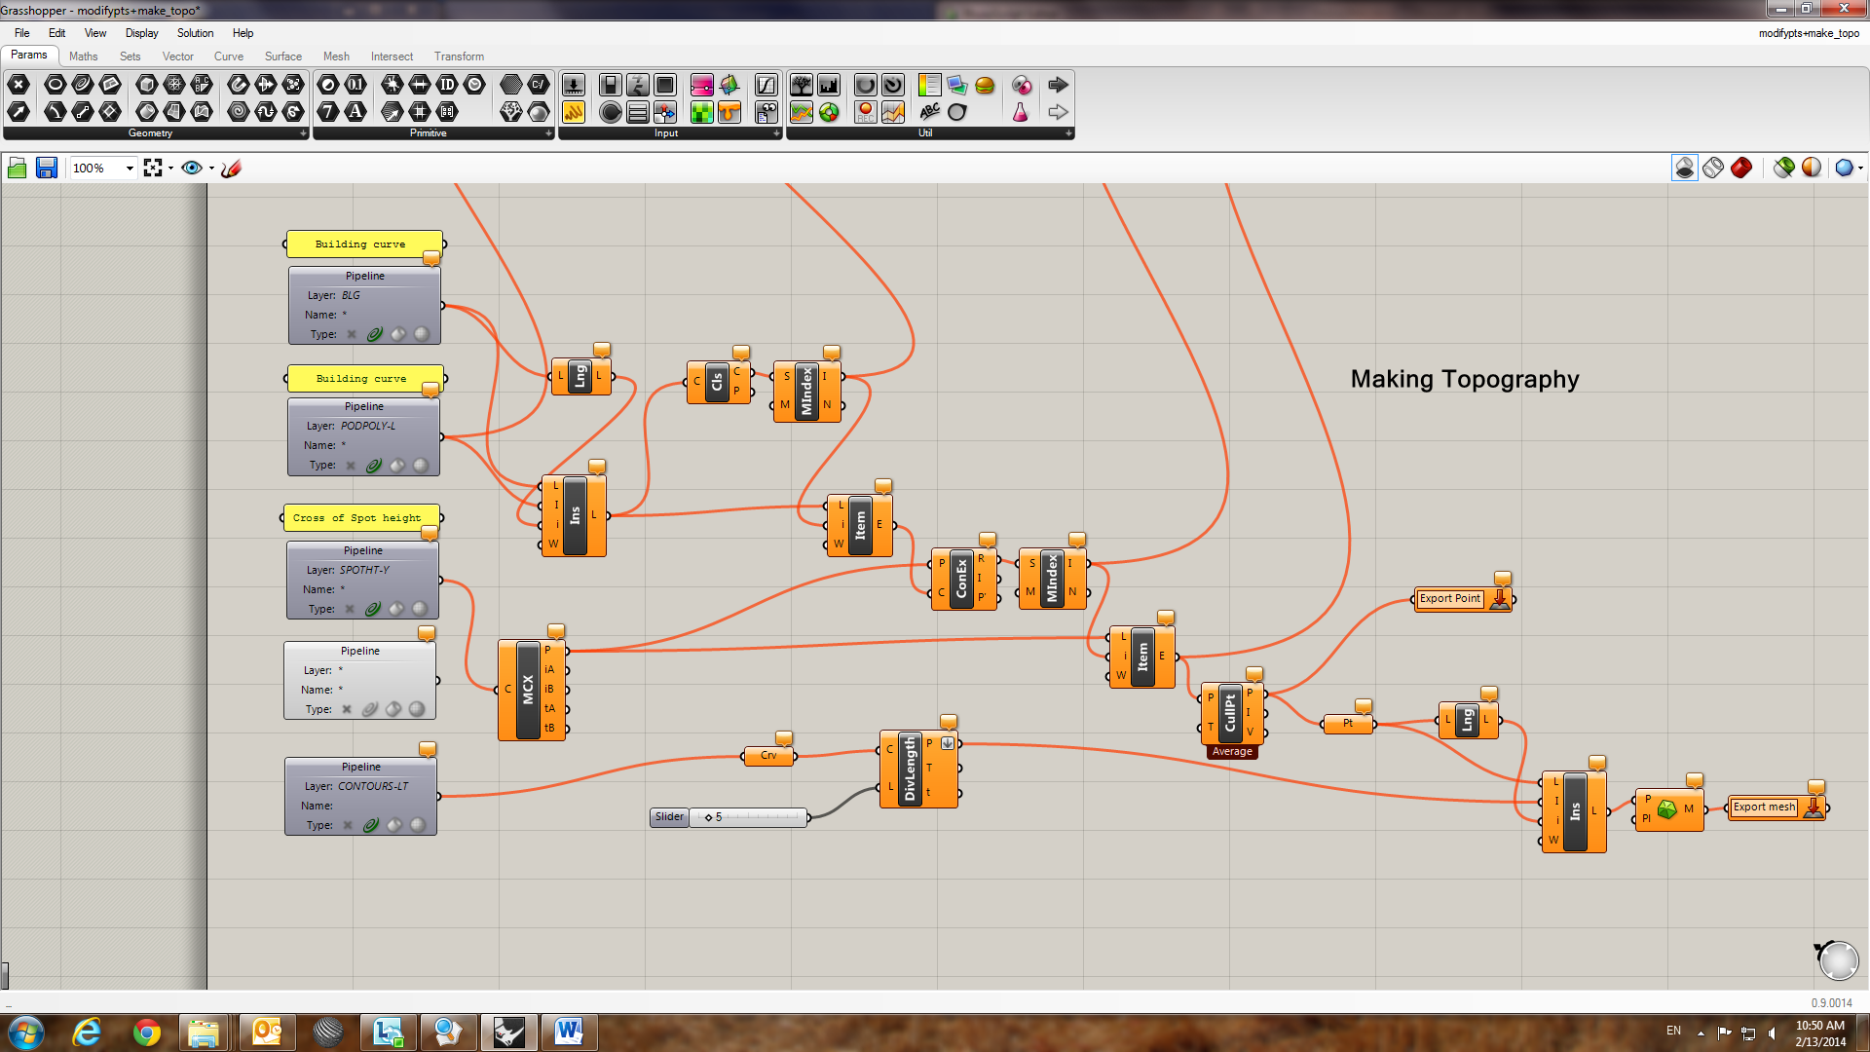

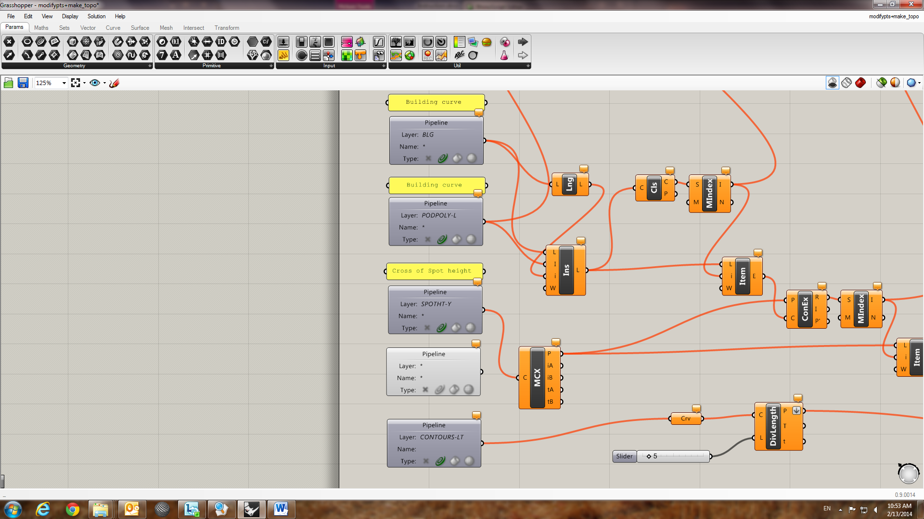

Some height data in GIS need to be excluded. Put all the curves which enclose such cross of height spots into one layer and input the layer name here

Exclude the height data located in the building site boundary curve in Rhino

All height data in GIS will be input

Grasshopper Tips:

Graft: set\tree

Function: make a list of values as individual value

Concatenate: set\text

Function: combine two as one

* 1. ICEM

Structured grid generation method:

Refer to: ~\Documents\ICEM@Instruction.pdf

~\Documents\ICEM@Instruction.ppt ICEM

Tips:

1. When the building curves and topography curves could not connect properly, and the mesh at that area is crushed, you can try to input the geometry of these two parts separately. (export topo as STL)
2. Auto reduction is a way to change the prism at some parts whose height are lower than the value set. Then redistribute prism edge (Edit Mesh-Move Nodes)
   1. CCM+

Pressure Drop Setting:

Refer to: ~\Documents\CCM@PressureDrop.xlsx

~\Documents\CCM@Pressure\_Drop@Pressure\_Loss\_Of\_System\_Components.pdf

Field Function:

1. Passive Scalar

Definition: $PassiveScalarL1 + $PassiveScalarL2

Modify Variable Name and ensure no space in the name

* 1. Ensight

Refer to: ~\Documents\Ensight@Command\_Manual.pdf

* 1. Contam
  2. Radiance

Installation:

1. Download Radiance win64 version from Radiance-online (direct to Github website)
2. Install and set environment variables (add ~/bin and ~/lib both to “Path”)
3. Install perl package
4. Done (successful in win 7)

Hong Kong Latitude Longitude Coordinate (22.3964 N, 114.1095 E)

In radiance (-a 22.3964 -o -114.1095) refer to ~\Doc\Radiance@UserGuide@Gensky.docx

Route : knowledgeManagement\BP Analysis\Script\RHINO\Radiance\NewRadcal8.rvb

Mesh Size Check: Selected object export as \*.stl

Before export geo, check the face direction first

**Radiation**

Tick all in both radiance object and working plane

1. Input “cmd” to working file (E: , cd filename\balabala)
2. ObjtoRad.bat
3. ObjtoVTK\_pts.bat
4. Modify the sky file (weather\_file.epw; find direct, diffused and reflected/global radiation; converted version; longitude; paste back to weatherfile; export as \*.csv; change extension name as \*.epw; perl makeskyfile < weathefile.epw | for solar radiation, use all day.sky file instead of the default sky.rad file, link *G:\bs\Team folders\BP Team\Knowledge Management\Technical Information\Microclimate Study\Solar Radiation\Sky File for Sim*)
5. Modify Material file (In solar heat gain study, set all materials 5 0 0 0 0)
6. Run\_WPlane (add “del model.oct”; “del model.opt”, sometimes add “$” in the scripts)
7. MergeResult.bat
8. VTKToTec.bat (ensight read by open, format: Tecplot.AscII, \*.output.dat)
9. Export \*.txt (CalArea.bat, modify it as “perl vtk2result.pl 0 P0\_0\_output.vtk result.text”)
10. Result (Total Amount/(Panel Area\*Number of suns)
11. Post\_Simulation (In solar heat gain case, define new variable=Irradiance\*10/42)
12. Scripts for running

cd P20

call ObjtoRad.bat

call ObjtoVTK\_pts.bat

call Run\_WPlane.bat

call MergeResult.bat

call VTKToTec.bat

cd..

cd P30

call ObjtoRad.bat

call ObjtoVTK\_pts.bat

call Run\_WPlane.bat

call MergeResult.bat

call VTKToTec.bat

Sunshadowing

1. Select a view in Rhino 5 (North perspective) (First class layer)
2. Run script (No luminance- mesh size 50/1)
3. Sky file
   1. Winter (!gensky 12 21 15:0 +s -a 22 -o -114)
   2. Summer (!gensky 6 21 15:0 +s -a 22 -o -114)
   3. Modify Create “CreateShadows.pl” accordingly
4. View file (0 1 0)
5. Material file (

Project Buildings color 5 1 0.83 0.02 0 0

Surrounds color 5 0.3 0.3 0.3 0 0)

1. Run (test one case)
2. Create Shadow
3. Run all.bat
4. Change “Extiff.bat” [pic -> hdr]

VDF

Untick working plane in radiance object and just tick in working plane

1. Use CIE overcast Sky file
2. Model.rif – Indirect 2
3. Material.mat – Paving(topo) 0.2, concrete(wall) 0.4

*[refer to ~\Doc\MC@VDF@Radiance@MaterialSetting@SA9 Extract from BS 8206-2-2008]*

1. CalArea (perl vtk2result.pl 0 VDF\_BLK1\_Kit\_1\_output.vtk output.txt)
2. Check geo.obj (some building surfaces are lost possibly)

Scripts:

call ObjtoRad.bat

call ObjtoVTK\_pts.bat

call Run\_WPlane.bat

Call VTKToTec.bat

call MergeResult.bat

call CalcArea.bat

Glare

1. Choose an appropriate view in Rhino and export geometry (set a proper view by making a line with 1.3m long away from the window and above grade 1.5m)
2. Modify view file exported, e.g.

* If looking from top or looking at top, the value should be 0 1 0 (Y is the north direction);
* If looking outside in a flat, it should be 0 0 1 (Z is the north direction ?)

1. Modify sky file with hong kong coordinate (22.3964, 114.1095) and proper time (Normally winter time, say 21th Dec), sky type
2. Modify model file, adding –av 1 1 1 at “Rendering line” (change background of images output), indirect 1 or 2
3. Modify material.mat

void plastic Surr

0

0

5 0.1 0.1 0.1 0 0

void plastic Topo

0

0

5 0.3 0.3 0.3 0 0

void plastic Wall

0

0

5 0.3 0.3 0.3 0 0

void glass Window

0

0

3 0.7 0.7 0.7

void plastic Ceiling

0

0

5 0.3 0.3 0.3 0 0

void plastic Glare\_Project

0

0

5 0.3 0.3 0.3 0 0

1. Modify CreateShadow file with proper time period and output file format
2. Change \*.pic to \*.hdr as for Extiff.bat, ExportTiff.bat, ExportHuman.bat
3. Run Glare\_2.bat to calculate DGI (daylight glare index)

When look from different view angles, DGI is different. Just pick the maximum value

(*E:\Personal\John\_Arup\Technical\_Backup\Instruction\Work\MC\Glare\Glare\_Copy\_Files*)

Scripts:

call ObjtoRad.bat

call CreateShadow.prl

call RunAll.bat

call Extiff.bat

call ExHuman.bat

call Exfalse.bat

TSI

1. Check surface direction
2. Select “Solar Irradiation (Working Plane)”
3. Untick the “working plane” in the first pop-up window and tick it in the second pop-up window
4. Copy sky file: “Summer\_AM\_Sky.sky” , “Summer\_PM\_Sky.sky”
5. Modify the “scene” in the “model.rif”
6. Modify “materials.mat” to “0,0,0,0,0” (default value is better)

(tree / pergola->glass 3 0.55 0.55 0.55)

1. Run “John”
2. Open “ \*\_output.dat ” by Ensight selecting the form of “Tecplot\_ASCII”
3. Solar Radiance = Irradiance/21
4. TSI\_AM = 1.2+0.115\*28.08+0.0019\*Rad-0.3185\*CaseMap\_V\_AM
5. TSI\_PM = 1.2+0.115\*30.46+0.0019\*Rad-0.3185\*CaseMap\_V\_PM
   1. IES

Refer to ~\Documents\MC@IES@Instruction.pptx

* 1. Excel VBA

Refer to: ~\Documents\ [VBA@Help\_Notes.txt](mailto:VBA@Help_Notes.txt)

~\Documents\VBA@Help\_Notes@ColorIndex.pptx

* 1. Word

1. Change page number

Under **Section Breaks**, click **Next Page**. On the page that follows the section break, double-click in the header area On the Design tab, in the Navigation group, click**Link to Previous** to turn it off.

1. Continue page number

Activate footer area, right-click page number, select continue page number

1. Insert reference

Insert Appendix and Section and reference number like [1]

1. Short cut

Alt + IBN insert all kinds of “break”

Ctrl + 1 first-order title

Ctrl + 2 second-order title

1. Very Good Advice from others
2. Refine the file management system to make the working process very clear and efficient. Most importantly, it would be possible to find them again after many months later.
3. Important data need to be kept for more than ten years. So keep them safe and easy to find. Especially, when there are many rounds study, make sure what is the purpose of each-round’s study.
4. When you receive a new project task, you must think though the working process. What will be needed, what is the problem, detail and draft a list clearly.

1. Cheung H D, Chung T M. Calculation of Mean Daylight Factor in a Building Interior within a Dense Urban Environment. Department of Building Services Engineering, Hong Kong Polytechnic University. [↑](#footnote-ref-1)